CHAPTER 8: The dynamic Earth
Worksheet 8.3

Folding and faulting
Answers

The San Andreas Fault
1. The following diagram and photograph shows the San Andreas Fault in California.

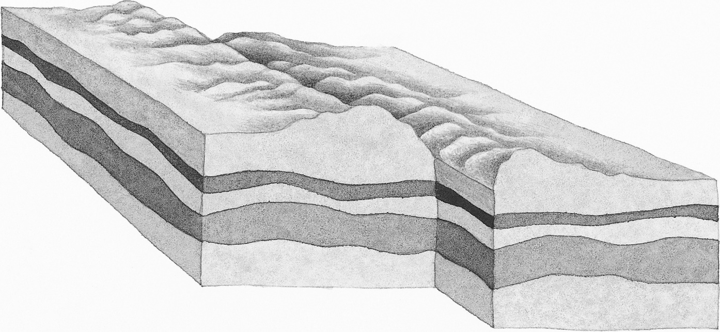

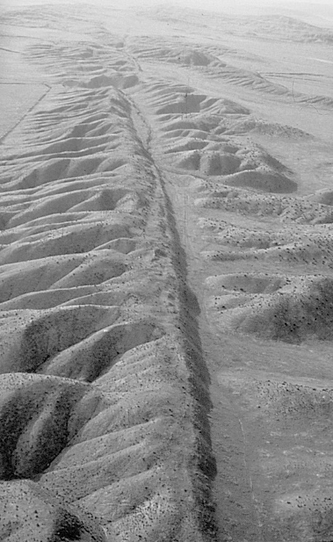  © Austral International/Rex Features | (a) Identify this type of fault.  Slip fault (or strike-slip fault or transform fault)  (b) On the diagram above use arrows to show the direction of the plate movement on either side of the fault line.  (c) What is produced when movement occurs along this fault line? ………………………………………….……....  Earthquakes

CHAPTER 8: The dynamic Earth

Worksheet 8.3

Page 2

Bending rocks
2. When rocks are squeezed deep in the Earth they may soften and bend rather than break.
Look at the supplied diagram below.
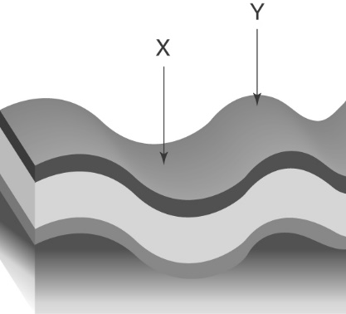 | (a) Identify the folds labelled X and Y.  Syncline  X:  Anticline  Y:
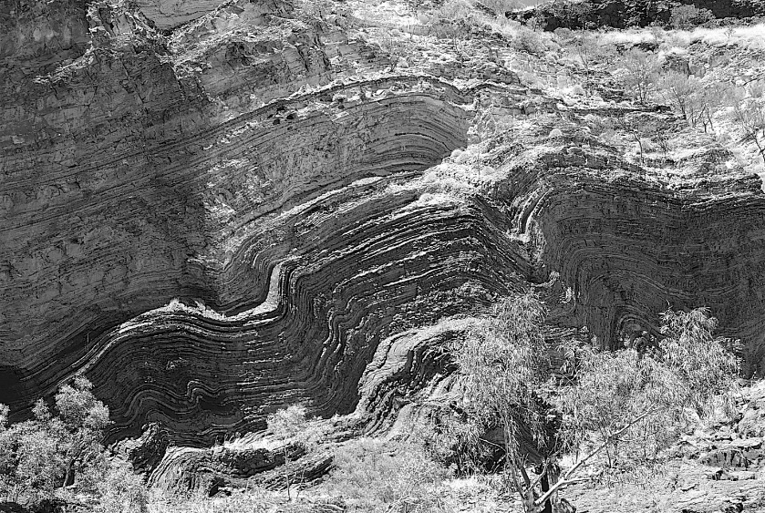  © ANT Photo Library/D. & T. O'Byrne |  | (b) The photo shows a section of rocks in the Hamersley range in Western Australia. Explain how these formations were produced.  Compression forces deep in the Earth squeezed and folded these rocks to form folds.

Normal and reverse faults
3. Draw and label 2D diagrams to distinguish between a normal and a reverse fault. Show the direction of rock movement along each fault.
Normal fault | Reverse fault
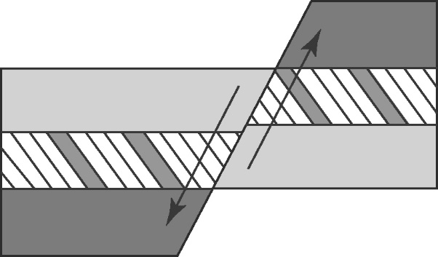 | 